 | Sinhgad Technical Education Society’s  RMD Sinhgad School of Engineering, Warje, Pune.  Department of Electronics & Telecommunication Engineering.

Name of Student
Division
Roll Number
Experiment Title
Marks

 | Sinhgad Technical Education Society’s  RMD Sinhgad School of Engineering, Warje, Pune.  Department of E&TC Engineering | Expt. No.  3
Title | BER performance over a wire line AWGN channel

Aim
Simulate BER performance over a wire line AWGN channel with BPSK transmission for SNR: 0 to 50 dB.

Apparatus
PC, Octave

Theory

BPSK Modulation:
In digital modulation techniques, a set of basis functions are chosen for a particular modulation scheme. Generally, the basis functions are orthogonal to each other. Basis functions can be derived using ‘Gram Schmidt orthogonalization’ procedure. Once the basis functions are chosen, any vector in the signal space can be represented as a linear combination of the basis functions.
In Binary Phase Shift Keying (BPSK) only one sinusoid is taken as basis function modulation. Modulation is achieved by varying the phase of the basis function depending on the message bits. The following equation outlines BPSK modulation technique.
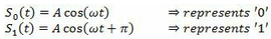
Here, A is the amplitude of the sinusoidal signal, is the carrier angular frequency measured in radians/second, t is the instantaneous time. S 0 (t) represents the carrier signal when ‘0’ is transmitted and S 1 (t) represents the carrier signal when ‘1’ was transmitted. The constellation diagram of BPSK will show the constellation points lying entirely on the x axis. It has no projection on the y axis. This means that the BPSK modulated signal will have an in-phase component (I) but no quadrature component (Q). This is because it has only one basis function.
A BPSK modulator can be implemented by coding the message bits using NRZ coding (1 represented by positive voltage and 0 represented by negative voltage) and multiplying the output by a reference oscillator running at carrier frequency ω.
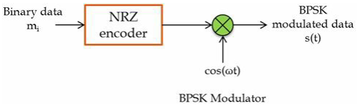

BPSK Demodulation:
For BPSK demodulator, a coherent demodulator is taken as an example. In coherent detection technique the knowledge of the carrier frequency and phase must be known to the receiver. This can be achieved by using a Costas loop or a Phase Lock Loop (PLL) at the receiver. A PLL essentially locks to the incoming carrier frequency and tracks the variations in frequency and phase. For the following simulation, neither a PLL nor a Costas loop is used but instead the output of the PLL or Costas loop is used. For demonstration purposes we simply assume that the carrier phase recovery is done and directly use the generated reference frequency at the receiver -cos(ωt).
In the demodulator the received signal is multiplied by a reference frequency generator (assuming the PLL/Costas loop is present). The multiplied output is integrated over one bit period using an integrator. A threshold detector decides on each integrated bit based on a threshold. Since an NRZ signalling format is used with equal amplitudes in positive and negative direction, the threshold for this case would be ’0′.

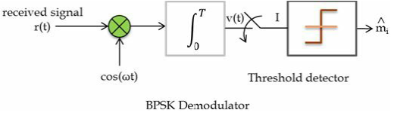

This concept is extended further to simulate the performance of BPSK modulation technique over an AWGN. Note that this is a baseband simulation of BPSK modulation and demodulation. Baseband simulation is faster and yields performance results same as that of pass band simulation.

Transmitter:
For the BPSK modulation, a series of binary input message bits are generated of which 1′s are represented by 1V and 0′s are translated as -1V (equivalent to NRZ coding).
AWGN channel:
For BPSK modulation the channel can be modelled as
$$y=ax+n$$
where, y is the received signal at the input of the BPSK receiver, x is the modulated signal transmitted through the channel, ‘a’ is the channel amplitude scaling factor for the transmitted signal usually assumed as unity. ‘n’ is the Additive Gaussian White Noise random variable with zero mean and variance$σ^{2}$.
For an AWGN channel, the noise variance in terms of noise power spectral density ($N_{0}$) is given by
$$σ^{2}=\frac{N_{0}}{2}$$
For M-ARY modulation schemes like M-PSK including BPSK, the symbol energy is given by
$$E_{s}=R_{m}R_{c}E_{b}$$
Where, $E_{s}$ =Symbol energy per modulated bit (x), $R_{m}=\log_{2}{M}$, (for BPSK M=2, QPSK M=4, 16QAM M=16 etc..,). R C is the code rate of the system if a coding scheme is used. In this example, since no coding scheme is used R c = 1. E b is the Energy per information bit.
Assuming $E_{s}=1$for BPSK (Symbol energy normalized to 1) E b /N 0 can be represented as (using above equations),
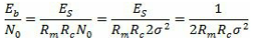
From the above equation the noise variance for the given ${E_{b}}/{N_{0}}$can be calculated as
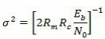
For the channel model “randn” function in Matlab is used to generate the noise term. This function generates noise with unit variance and zero mean. In order to generate a noise with sigma for the given E b /N 0 ratio, use the above equation, find , multiply the “randn” generated noise with this sigma, add this final noise term with the transmitted signal to get the received signal.

Receiver:
BPSK receiver can be a simple threshold detector which categorizes the received signal as ‘0’ or ‘1’depending on the threshold that is being set.
Considering a binary symmetric channel, where the a-priori probabilities of 0’s and 1’s are equal, the decision threshold can be conveniently set to T=0. The comparator decides whether the projected symbols are falling in region A or region B. If the symbols fall in region A, then it will decide that 1was transmitted. It they fall in region B, the decision will be in favor of ‘0’.
For deriving the performance of the receiver, the decision process made by the comparator is applied to the underlying distribution model. The symbols projected on the axis will follow a Gaussian distribution. The threshold for decision is set to T=0. A received bit is in error, if the transmitted bit is ‘0’ & the decision output is ‘1’. Similarly, the received bit is considered to be in error - if the transmitted bit is ‘1’ & the decision output is ‘0’.
This is expressed in terms of probability of error as,
Or equivalently,
By applying Bayes Theorem, Q functions and error functions, we can write,

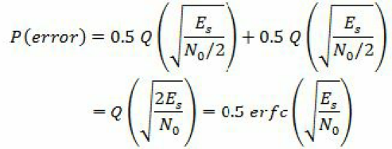
For BPSK, since E S =E b , the probability of symbol error (P S ) and the probability of bit error (P b ) aresame. Therefore, expressing the P S and P b in terms of Q function and also in terms of complementaryerror function:
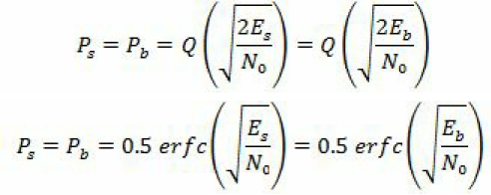

 | Sinhgad Technical Education Society’s  RMD Sinhgad School of Engineering, Warje, Pune.  Department of E&TC Engineering | Expt. No.  3
Title | BER performance over a wireline AWGN channel
 | Student Worksheet

Problem Statement
Simulate BER performance over a wire line AWGN channel with BPSK transmission forSNR0 to 50 dB

Formulae
$$R_{m}=\log_{2}{M}$$
$$noiseSigma, σ=\sqrt{\frac{1}{2R_{m}R_{c}\frac{E_{b}}{N_{0}}}}$$
$$P_{b}=0.5 erfc\sqrt{\frac{E_{b}}{N_{0}}}$$

Conclusion
This program for the bit error rate (BER) performance of BPSK modulation in an Additive White Gaussian Noise (AWGN) channel is simulated. The simulation is performed at baseband so there is no need of a carrier and sampling rate of 1 sample/symbol, or 1 sample/bit is used. The simulation is done using real numbers since we do not need to model two orthogonal carriers as we would need to do for QPSK modulation.

Review Questions
- Comparison of Analog Modulation Schemes with Digital Modulation.
- Mention theoretical bandwidth efficiency limits for each modulation formats.
- List services and features of different generations of cellular networks.
- Explain the BPSK in detail.
- What is the bit error rate?

 | Sinhgad Technical Education Society’s  RMD Sinhgad School of Engineering, Warje, Pune.  Department of E&TC Engineering | Expt.No.  3
Title | BER performance over a wire line AWGN channel
Name
Roll No.

Program
% Demonstration of Eb/N0 Vs BER for BPSK modulation scheme
- clc;
- clear all;
- N=1000000; %No. of bits within which error bits are to be calculated
- SNRdb=0:1:50; %Given Data
- SNR= 10.^(SNRdb/10); %SNR In dB
- BER= qfunc((SNR).^0.5); % Use of Q in BPSK
- BERdb=10*log10(BER); %Bit Error Rate In decibel
- BERdb_perbit=BERdb/N; % Bit Error Rate per bit
- plot(SNRdb,BERdb_perbit,'b');
- xlabel('SNR in Decibel');
- ylabel('BER in Decibel');
- grid on;

Output

